Motion and Force in a Gravitational Field

Revision Problems 5: Torque and Equilibrium Due: ______________

Name: _________ ANSWERS ___________________ (20 marks total)
- We say that objects are more stable if they have a wide base and a low centre of gravity. Explain this using the concept of torque. (3 marks)

Objects with a low centre of mass and wide base have a large restoring torque when tilted.
[1 mark]
Due to wide base, centre of mass is some distance from the edge of the base so torque tends to rotate object back to centre. [1 mark]

Object has to rotate through a large angle before centre of mass is beyond base which would then provide a torque to tip object over. [1 mark]

- Label the following diagrams as stable, unstable or neutral. (3 marks)

unstable neutral stable [3 marks]
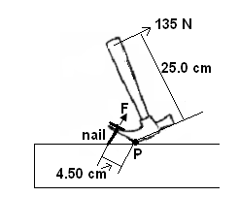
- A claw hammer is be used to remove a nail from a piece of wood as shown. Calculate the pulling force, F, in the situation shown? (2 marks)

ΣCM = ΣACM
135 x 0.25 = F x 0.045 [1 mark]
33.75 = 0.045F
F = 750 N

F = 7.50 x 10² N [1 mark]

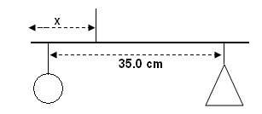

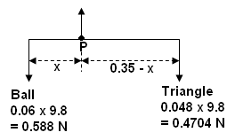
- A child’s mobile has different shapes at each end of a 35.0 cm rod (assume mass of rod is insignificant). The mass of the ball is 60.0 g and the mass of the triangle is 48.0 g. How far from the triangle should the rod be suspended to hang horizontal? (4 marks)

ΣCM = ΣACM
0.470 x [0.35 - X ] = 0.588 x X [2 marks]
0.1645 – 0.47X = 0.588X
0.1645 = 1.058X
X = 0.1554 [1 mark]

attach string to rod 0.155 m from ball [1 mark]

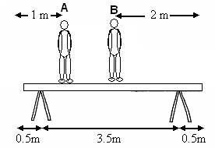
- In order to paint a wall, two men are standing on a supported uniform plank of mass 15.0 kg as shown. (diagram not to scale). Man A, who has a mass of 90.0 kg is 1.00 m from one end while man B, who has a mass of 70.0 kg is 2.00 m from the other end. The supports are 0.500 m from each end of the plank. Calculate how much of the total weight each of the trestle stands supports.
(4 marks)

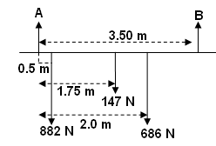

Take moments about A F up = F down
ΣCM = ΣACM 591.5 + A = 882 + 147 + 686
(882 x 0.5) + (147 x 1.75) + (686 x 2.0) = B x 3.5 A = 1715 – 591.5
441 + 257.25 + 1372 = 3.5 B = 1123.5
2070.25 = 2.5 B

B = 592 N up A = 1.12 x 10³ N
[2 marks] [2 marks]

- A traffic light hangs from a structure as shown. The uniform metal pole AB is 5.50 m long and has a mass of 6.00 kg. The mass of the traffic light is 12.0 kg. The cable CD is attached 0.800 m from point A. Determine the tension in the horizontal cable CD. (Assume the cable has no mass itself.) (4 marks)

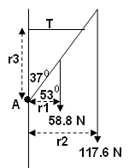
Calculate perpendicular distance:

r₁ = 2.75 cos 53
= 1.6550 m [1 mark]
r₂ = 5.5 cos 53
= 3.3100 m [1 mark]
r₃ = 0.800 m

Take moments about A

ΣCM = ΣACM
(58.8 x 1.655) + (117.6 x 3.31) = T x 0.80) [1 mark]
97.314 + 389.256 = 0.80T
486.57 = 0.8T
T = 608 N [1 mark]

